Academic English
Winter SIS code: NJAZ115
Summer SIS code: NJAZ093
Lecturer: PhDr. Miluša Bubeníková, Ph.D.

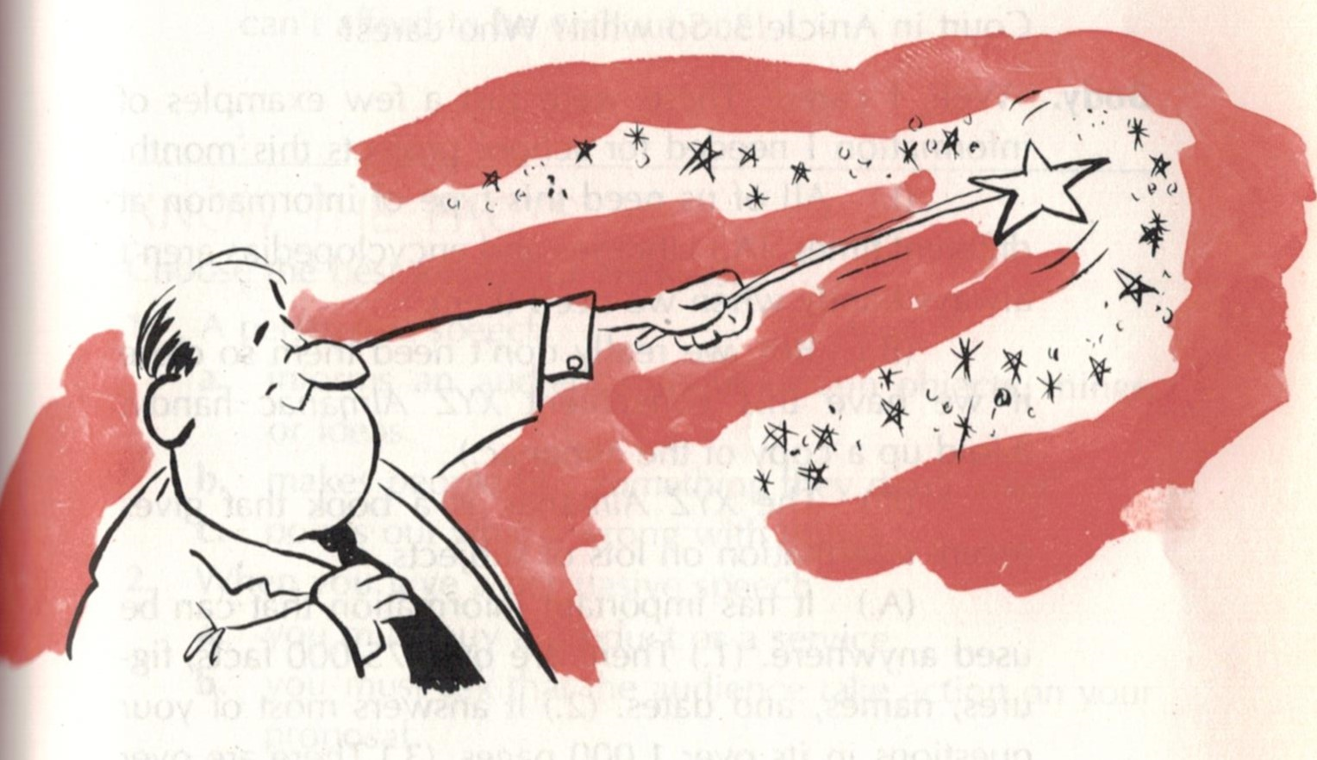
An elective language course designed for highly motivated Master and Doctoral students wishing to improve their understanding of and proficiency in academic English, written and spoken.
During the term each student must give a presentation or participate in a panel discussion. Academic vocabulary, grammatical forms and special structures, as well as various genres of academic style are studied and practised.

Time and place: Wednesday 13:10 V107 Troja
Contact: milusa.bubenikova@matfyz.cuni.cz

